Project Update 1

Team #: B7
Team Members: Damian Grochowski, Ryan Whitehouse, Ole Nagorsen, Michael Lee, Reid Brock

How are we cleaning the data?
When looking at the medical insurance dataframe info we notice that the attributes “age” and “smoker”, which should be integers, are of type object. Upon closer inspection of the data, we see that some rows in these columns contained a question mark in place of the value. We assume that these question marks represent null values. We then sum up the amount of null values in age, which is equal to 4 and smoker, which is equal to 7 for a total of 11 null values in the dataframe. In order to clean the data, we create a variable “row_with_null” that contains an index of all rows with a “?”. We check the length of the index to see that there are 11 rows with a null value in at least one of the columns (equal to the sum of age and smoker null values). Then we clean the data by dropping all the rows with the missing value and converting the “age” and “smoker” columns into integers.

Preliminary Findings
There is a strong correlation between positive correlation between smoking and insurance (we go more into depth in the correlations and relationships section). The average insurance price for a smoker is over $30,000, while it is just under $10,000 for a non-smoker. The average insurance price for men is slightly higher than for women. On average, our model prediction for insurance price is off by about $2,213 using MAE, and $4,310 using RMSE. Our model has an R^2 score of 0.872, meaning it explains about 87.2% of the variance in actual insurance prices. Using our Gradient Boosting Model Reduced Model, we achieved an MAE of 1399.83, an MSE of 10641464.91, and an RMSE of 3262.13, as well as an R^2 score of 0.923. Using the feature importances from our best decision tree regressor model, we find that smoking exhibits the highest importance on insurance price (0.62), followed by BMI (0.21) and age (0.13) (Figure 1). The high importance of smoking, BMI, and age caused us to continue focusing more specifically on the effect they have on insurance costs.

Correlations and Relationships
As mentioned previously, there is a strong positive correlation of 0.8 between smoking and insurance price. If a person smokes (changes from 0 and 1), this tends to lead to an increase in that person’s insurance price. However, this does not suggest that smoking causes an increase in insurance prices, but rather it suggests that these two variables are strongly linked. Based on a scatter plot (Figure 2), there appears to be a moderate positive relationship between BMI and insurance price: as BMI increases, the insurance price per customer also increases, especially among those who smoke. Age and insurance price (Figure 3) also have a positive correlation, as older individuals who are smokers tend to have a higher insurance price. Other underlying factors possibly influencing these relationships and correlations that our dataset does not quantify could be lifestyle habits of their patients, underlying health conditions, family health history, and patients’ diet and nutritional intake.

Insight into our Process
Our plan is to find the factors that impact insurance premiums. Because of this, we are monitoring the health-related traits of the records in regards to the cost of their insurance. Because of this method we have been able to make our heavy connections between smoking and having a high BMI to a high insurance cost. We wanted to present this through a visual medium, which led us towards creating the regressions and the scatterplots used in this update. We believe that by visualizing the records, we can present our insights in a more effective way. In the future, we are planning to create further visualizations and explanations for the findings that we continue to adapt through regression processes.

Preliminary Story
The initial story we are recognizing when looking at regressions is the nature of our prevalent variables being smoking, BMI, and age. When examining our age and price regression (Figure 3), there are three separate trendlines which follow a concentration of smoking/ at-risk behavior. This led us to research health premium pricing through which we learned about risk pools which health insurers will use to categorize customers into pools of risk behaviors, such as BMI and smoking, and then assign prices based on which pool a user falls within. Insurance firms then package that insurance to sell on the insurance market. There are also flat increases to price based upon specific values. Another article we read from 1991-2011 found consistent increases to prices based on singular variable differences such as obesity leading to an average yearly price increase of $1360 for obesity and $1046 for smoking behavior in 2011. There is a separation in magnitude between our data set’s number and the studies’ values, but the increase based on risk behaviors is clearly stated. We want to explore this method of price packaging that insurance companies employ further and see whether our findings can be used by insurance customers to estimate whether they are over or underpaying for their insurance based on their physical attributes and behaviors.

.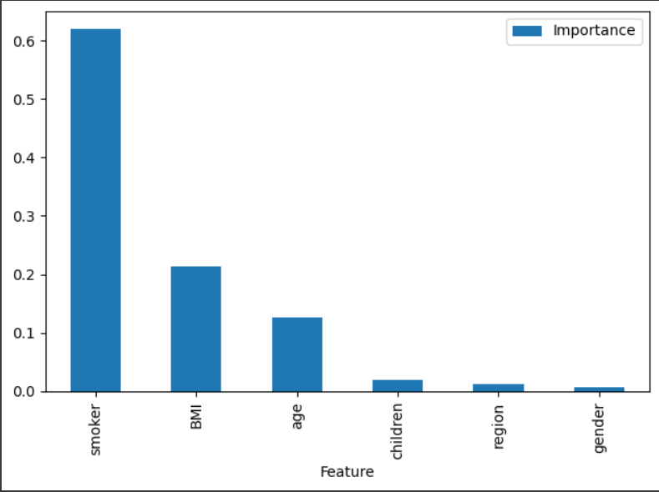
Figure 1.

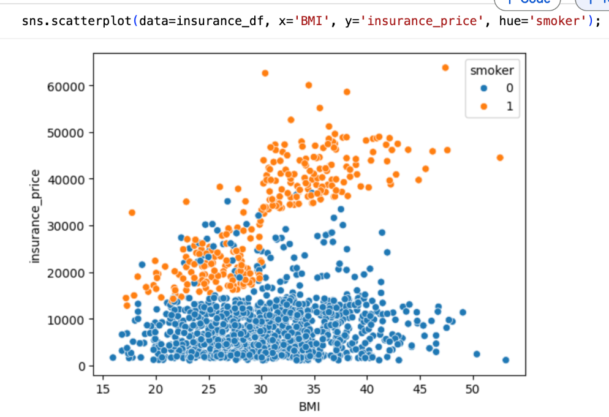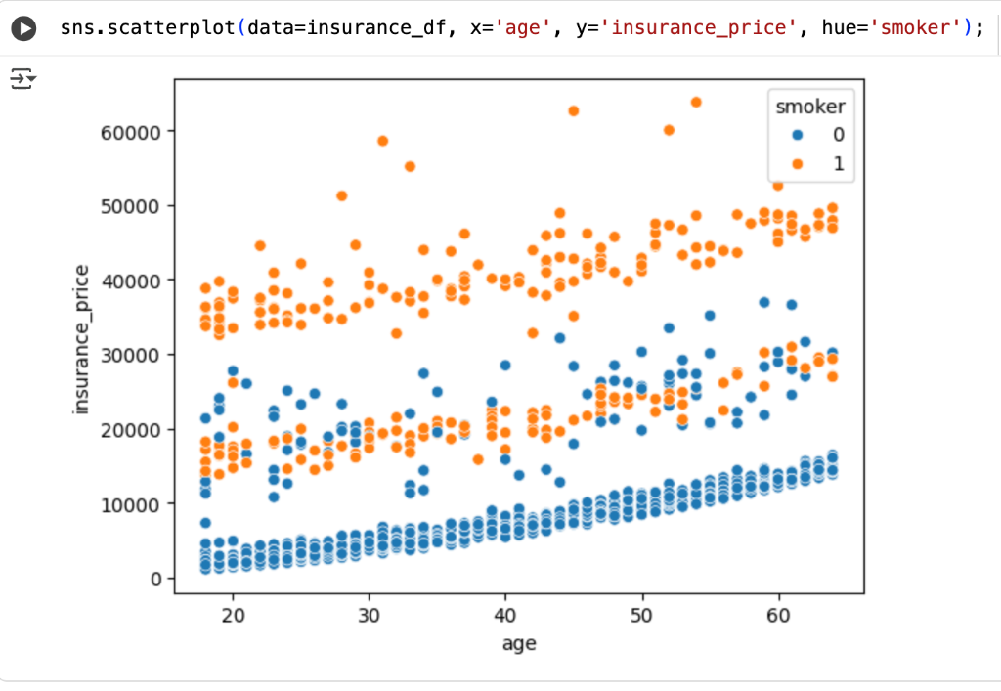

Figure 2. Figure 3.

Porrini, Donatella. 2015. "Risk Classification Efficiency and the Insurance Market Regulation" Risks 3, no. 4: 445-454. https://doi.org/10.3390/risks3040445
An R. (2015). Health care expenses in relation to obesity and smoking among U.S. adults by gender, race/ethnicity, and age group: 1998-2011. Public health, 129(1), 29–36. https://doi.org/10.1016/j.puhe.2014.11.003

